* Open sendgrid.com and go to the pricing page, click start free.
  + 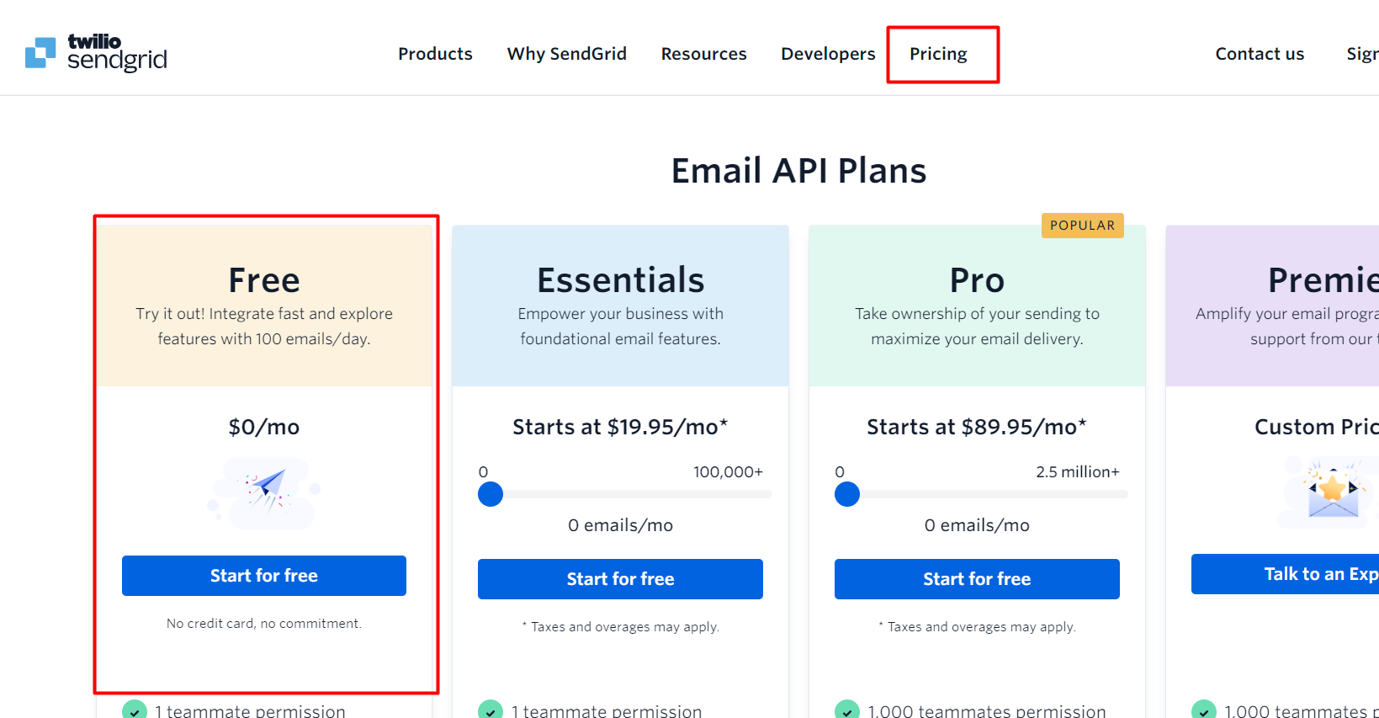
* Sign in page will come then click on the sign in with google:
  + 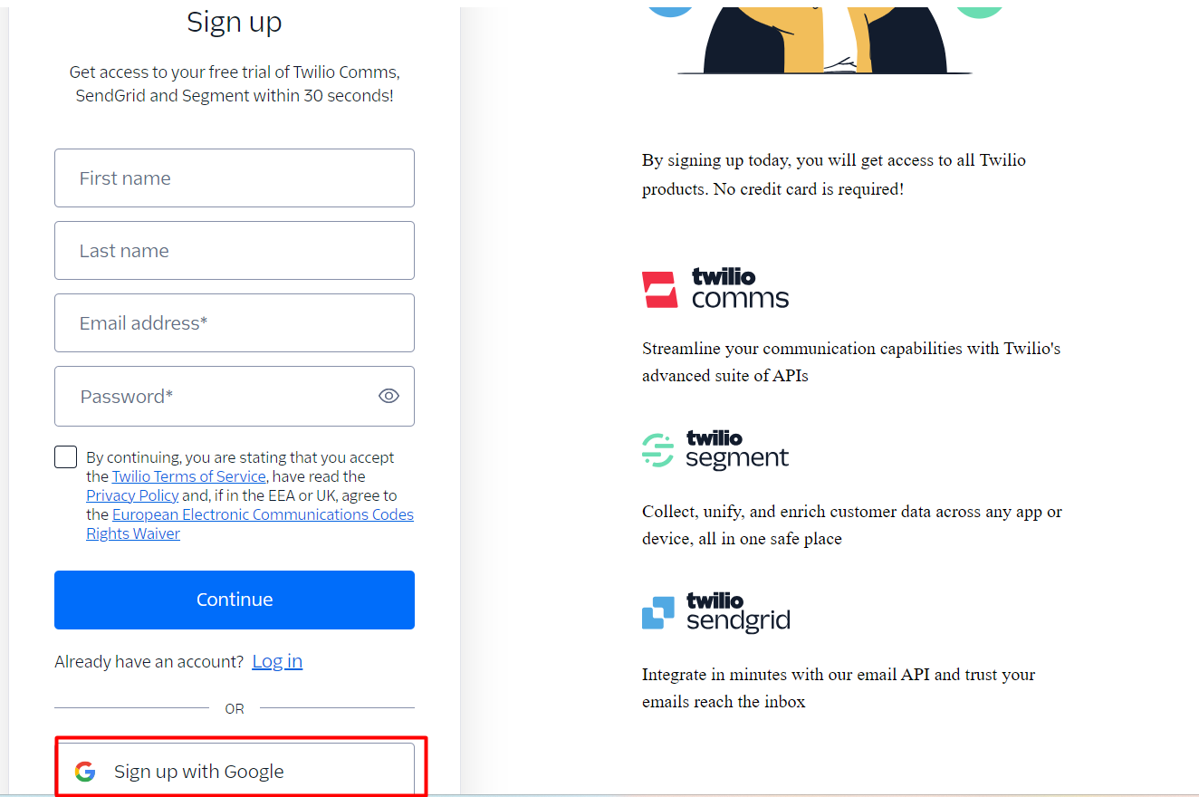
* Add your phone number:
  + 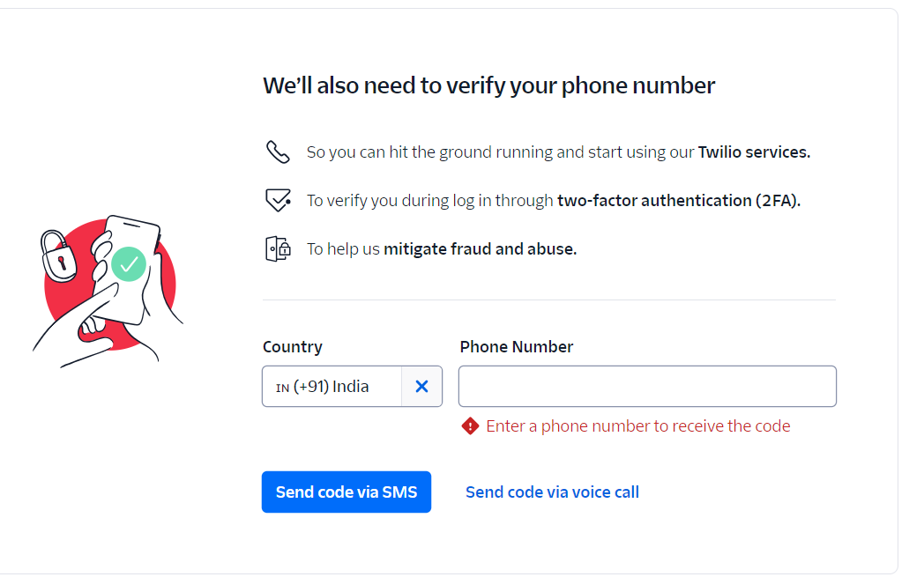
  + Otp will be sent to your mobile and then after verification you need to save the recovery code somewhere safe.
* Fill the info:
  + 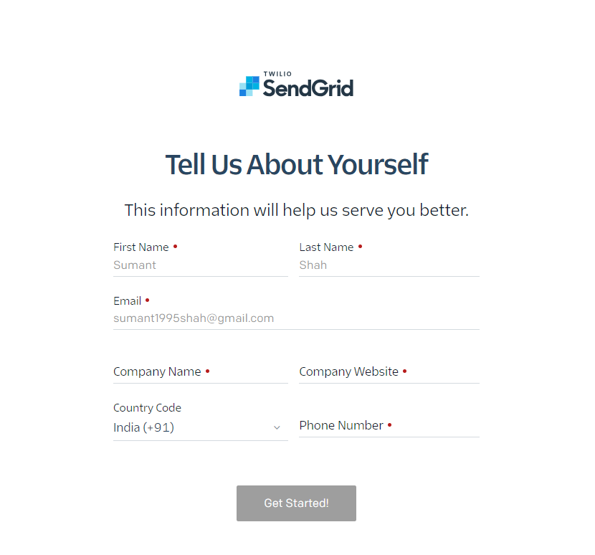
* We need to create a sender first:
  + 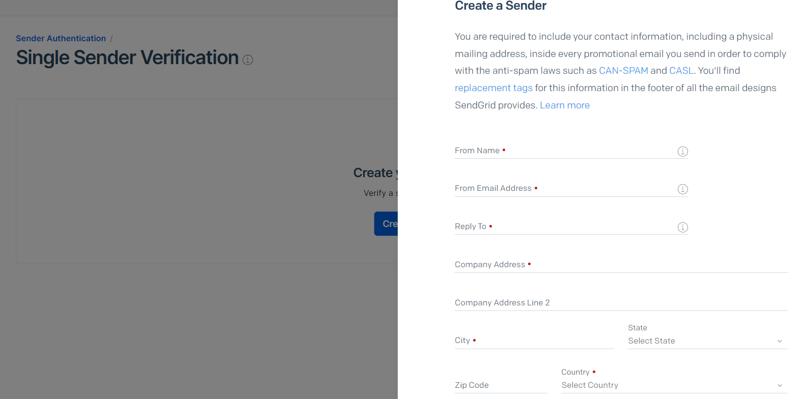
* Then it will send the sample mail and verify single sender link will be send to your main mail id.
* After verifying the step 1
  + 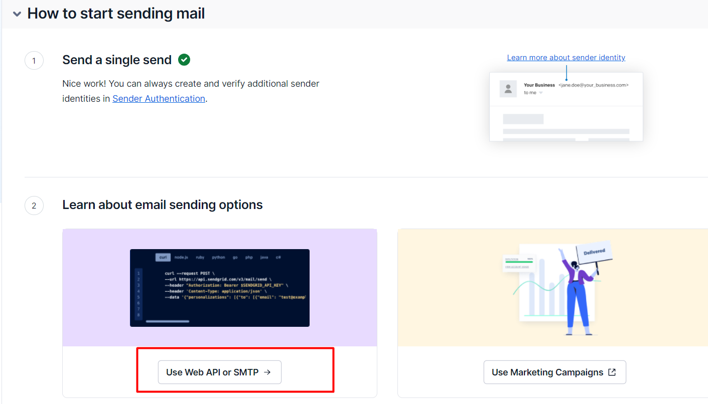
  + click on use web api or smtp
  + click web api
  + click node js
* After that
  + 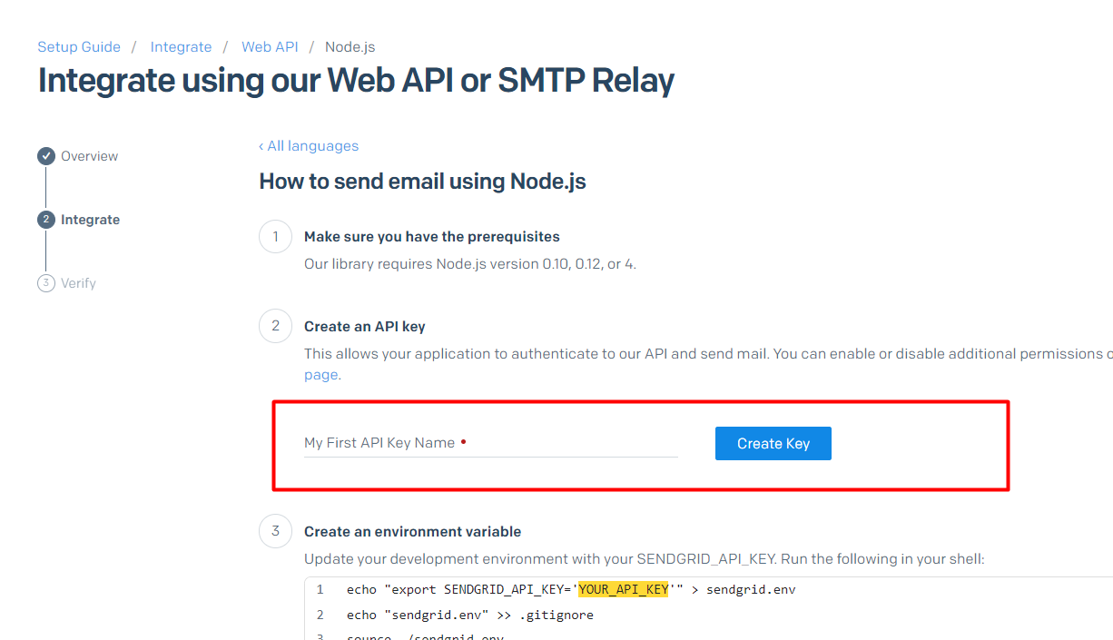
  + Create api key name. Here you can write any name e.g. “Task app” and then click on create key, then it will create key which we need in our project.